luuswp 2021/22

University of leeds swimming and water polo
  - Sponsorship Brochure

Table of Contents
1. Executive Summary 3
2. Club overview and Our Goals 4
3. Timeline of 2021-22 Events 5
4. How will your sponsorship benefit you? 7
5. How will your sponsorship help us? 8
6. Sponsorship packages 9

Executive Summary
Leeds University Swimming and Water Polo is one of the largest mixed societies at the University of Leeds. With over 200 members and a friendly yet competitive atmosphere, every year our committee look for new sponsorship. This brochure details the benefits your company and our members would yield should you be inclined to sponsor us for the academic year of 2021/22.

Club overview and Our Goals
Club Overview

As mentioned, we are a competitive society with swimmers competing at high levels in the British Universities and College Sports competitions (BUCS) and we offer memberships to swimmers and water polo players to train in 1-8 sessions a week. We welcome swimmers and water polo players of all abilities, and our memberships differ depending on your level. Because of this, also have a very active social scene including weekly socials after matches and a tour to Croatia in Easter.
Above all, we are a society that helps develop our members, providing them with skills and experiences that are far more useful than swimming itself. We have a strong community and a large support network which has been developed in the last year to include welfare secretaries. This culture upholds the core values behind university societies and promotes the true roots of our sports.

Our Goals

We hope in the coming year, with the help of your sponsorship, we can continue our momentum and continue to succeed in BUCs matches and Galas. With a new set of freshly enthusiastic committee members, we all believe that we can flourish as a society this year despite obstacles that we may be faced with due to COVID-19. We hope that you can join us in achieving our goals and surpassing them.

We look forward to raising money for charity by arranging events such as the Yorkshire Three Peaks. In 2020/21 during FitFeb, we collaborated with other societies to exceed our fundraising goals for Stonewall and we hope to be able to hit similar targets again.

Timeline of 2021-22 Events
Please see below a timeline of events that take place throughout the LUUSWP calendar. Some are opportunities for advertisement of your company, which are marked with (*).
October
Freshers Fair*| An event during Freshers’ Week where we showcase ourselves to thousands of new students along with many students looking to start something new
Trials and Welcome drinks | Trials for squads take place throughout freshers week. We welcome all new members with introductory drinks at the end of the week.
Varsity* | One of the most important events of the year where we compete against Leeds Beckett University in all sports including swimming and water polo.
BUCS Polo matches begin*

November
Otley Run | One of our infamous social events of the year. Alumni return to meet all our new members and see all their old friends. BUCS short course*| One of the most important competitions of the year for our swimmers.
Sponsored Charity Event* | Our first sponsored charity event of the year, the Charity Gala. Swimmers and Polo players all take part in a mixture of fun and serious races.

December
Christmas Meal | The annual Christmas dinner involves the whole club getting dressed up for a sit down meal.

February/March
Sponsored Charity Event* | Our second sponsored charity event of the year. This event involves some very competitive water polo matches between the swimmers and the polo players.
BUCS long course* | Similar to BUCS short course however this time the swimmers compete in a 50m pool.

April
Water polo finals* | BUCS finals which would allow us to mix with hundreds of students from across the country. If either our boys or girls teams reach this finals, it is a huge achievement.
AGM | A full club meeting at which the executive committee positions for the new academic year are decided, handovers are made, and presentations are given.
New Committee Appointed
Tour | Both swimming and water polo go on a foreign tour, where we play and race against several different universities offering a friendly, competitive and fun trip as a club.

May
Otley Run | Very similar to our first one in November but with a different theme!

How will your sponsorship benefit you?
Sales| Naturally you will have members from our 200-strong society purchase your product or service, or at least will have gained interest in your company. So if not for an immediate increase in sales from our members, your company will be word of mouth in the student community of Leeds, which will encourage an increase in sales by students who are both in and exterior to our society. You may wish to liaise with us as to how we could do more here. For instance, a discount coupon for each of our members would help drive your company’s sales.

Competitions and Events | Besides advertising your company around Leeds in the form of the events and the connections that we hold, we can also offer vast exposure across the country with our many away days. Our water polo teams play at over 20 away games a year between them, seeing students from London to Scotland. Furthermore, our swimming team regularly competes at major venues. Often drawing many of the general student population to watch and overall equating to an estimated exposure of over 300,000 students a year.

Social Media | We currently run both a Facebook and Twitter page, where we let our followers know about our up-and-coming events, recent achievements, and current club news with over 1,200 followers between them. There is the availability for you to post on these accounts through liaising with our media secretary. There will also be various opportunities for us to reach hundreds more students at non-sporting events, such as our annual charity event, the AGM meeting and weekly socials.

How will your sponsorship help us?
Throughout the year both swimming and water polo require pool time and transport in order to be prepare for and attend matches or galas. The societies costs for such hire, coaching and transport can amount to over £6000 per year. With your financial backing we will be able to cover these with ease and provide our members with a platform to succeed and thrive.
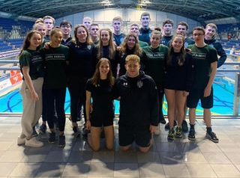
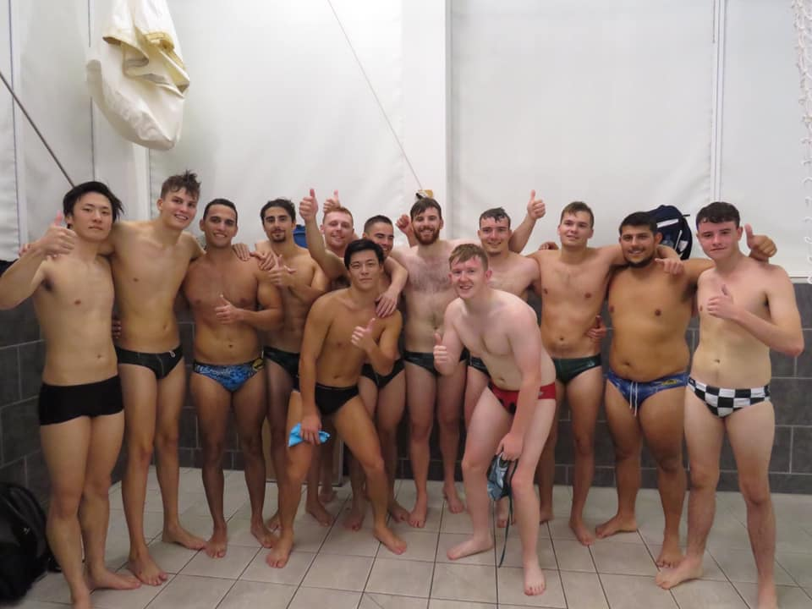
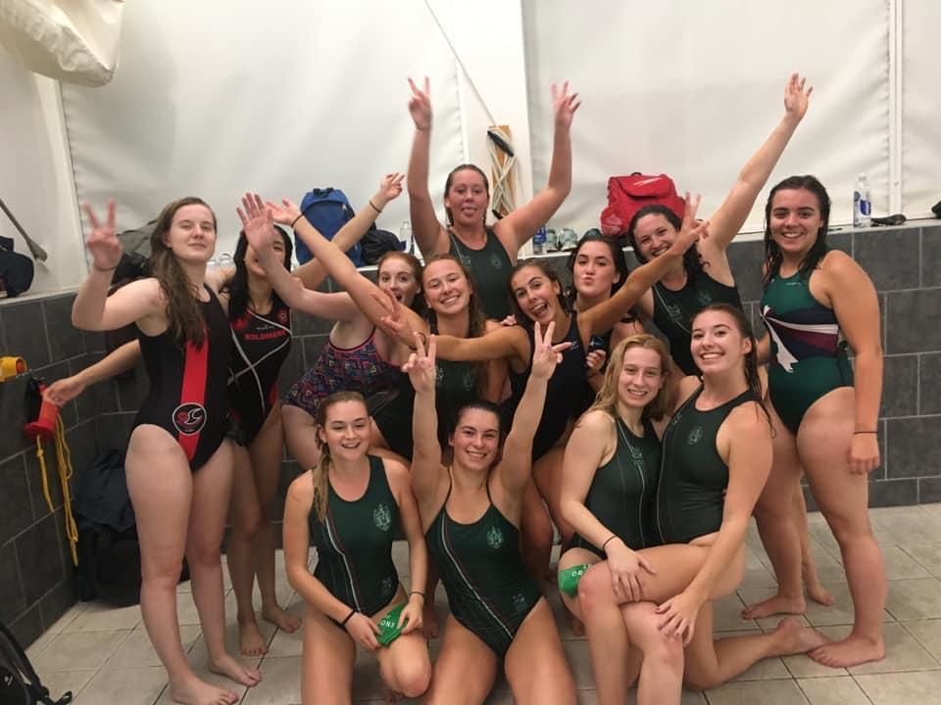

Sponsorship packages
Gold |£750
- Promotion at Freshers Fair (personalised pull-up banner and promotional material). Potential reach is 10,000 students.
-Promotion at BUCS matches and galas (personalised pull- up banner and potential promotion on team kit). The reach from such events can be up to 300,000 students.
-Company Logo displayed on jumpers and kit, bought and worn by potentially 200 members worn throughout the year.
- Company sponsored charity events (banners and customised kit can be used to promote)
-Advertisement on social medias (we have over 1200 followers across our platforms). This can include a monthly promotional post.
-Company Logo displayed on LUUSWP logo which will be displayed on social medias and SWP website.
- Opportunity to send targeted messages to all SWP members 6 times a year.
Silver | £500
-Advertisement on any campus events you wish to undertake. -Monthly promotional post on social media platforms. -Opportunity to send targeted messages to all SWP members 3 times a year.
- Logo displayed on social media platforms, including the website.
Bronze | £300
-Logo displayed on social media platforms, including website.

